**# Hypothesis 1a - Org Advancement, broad succession periods**

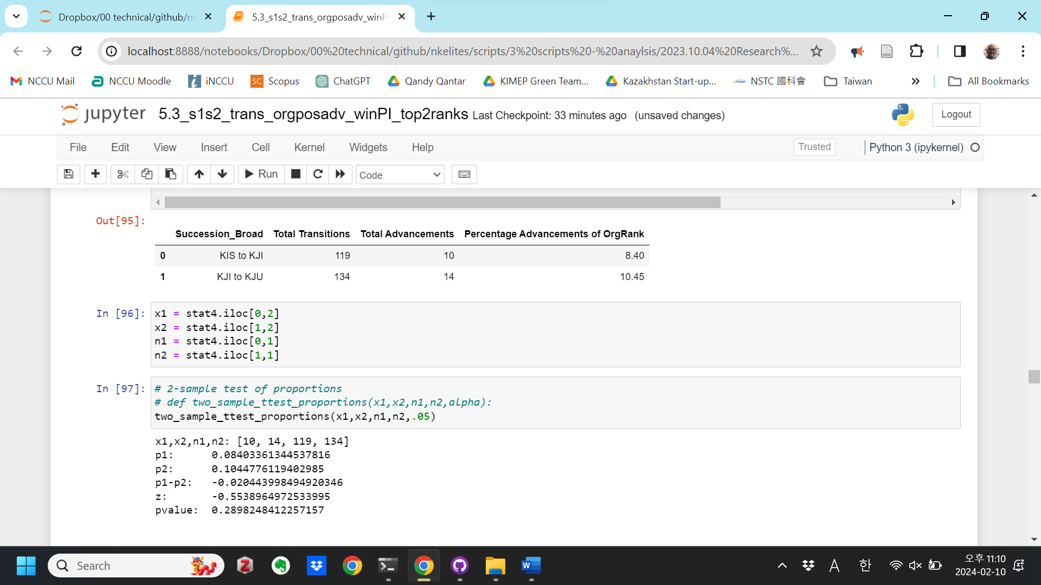

**# Hypothesis 1b - Position Advancement, broad succession periods**

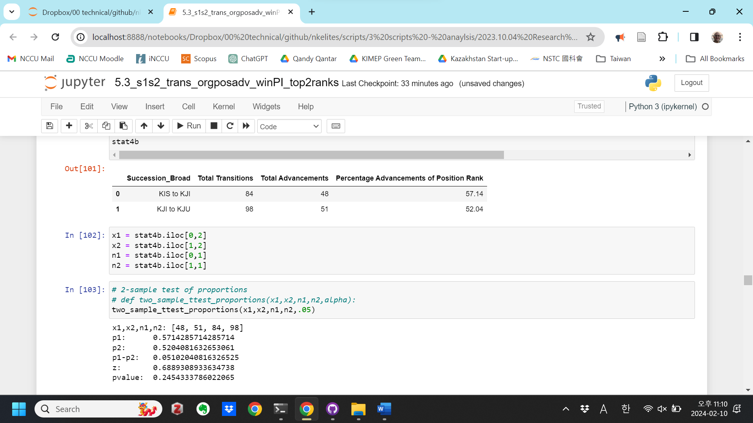

**# Hypothesis 1c - Org Advancement, broad succession, by Institution**

Government

Succession_Broad Total Transitions Total Advancements \

0 KIS to KJI 62 7

1 KJI to KJU 96 11

Percentage Advancements of OrgRank

0 11.29

1 11.46

x1,x2,n1,n2: [7, 11, 62, 96]

p1: 0.11290322580645161

p2: 0.11458333333333333

p1-p2: -0.001680107526881719

z: -0.032456135798665166

pvalue: 0.48705414807304515

Social

Succession_Broad Total Transitions Total Advancements \

0 KIS to KJI 24 3

1 KJI to KJU 16 1

Percentage Advancements of OrgRank

0 12.50

1 6.25

x1,x2,n1,n2: [3, 1, 24, 16]

p1: 0.125

p2: 0.0625

p1-p2: 0.0625

z: 0.6454972243679028

pvalue: 0.25930250821436274

Party

Succession_Broad Total Transitions Total Advancements \

0 KIS to KJI 26 0

1 KJI to KJU 0 0

Percentage Advancements of OrgRank

0 0.0

1 NaN

x1,x2,n1,n2: [0, 0, 26, 0]

p1: 0.0

p2: nan

p1-p2: nan

z: nan

pvalue: nan

Military

Succession_Broad Total Transitions Total Advancements \

0 KIS to KJI 7 0

1 KJI to KJU 22 2

Percentage Advancements of OrgRank

0 0.00

1 9.09

x1,x2,n1,n2: [0, 2, 7, 22]

p1: 0.0

p2: 0.09090909090909091

p1-p2: -0.09090909090909091

z: -0.8267416062480969

pvalue: 0.20419176683513363

**# Hypothesis 1d - Position Advancement, broad succession, by Institution**

Government

Succession_Broad Total Transitions Total Advancements \

0 KIS to KJI 39 27

1 KJI to KJU 75 29

Percentage Advancements

0 69.23

1 38.67

x1,x2,n1,n2: [27, 29, 39, 75]

p1: 0.6923076923076923

p2: 0.38666666666666666

p1-p2: 0.30564102564102563

z: 3.096841647953146

pvalue: 0.0009779716358979673***

Social

Succession_Broad Total Transitions Total Advancements \

0 KIS to KJI 15 13

1 KJI to KJU 9 8

Percentage Advancements

0 86.67

1 88.89

x1,x2,n1,n2: [13, 8, 15, 9]

p1: 0.8666666666666667

p2: 0.8888888888888888

p1-p2: -0.022222222222222143

z: -0.1593638145779186

pvalue: 0.43669112315483205

Party

Succession_Broad Total Transitions Total Advancements \

0 KIS to KJI 25 3

1 KJI to KJU 0 0

Percentage Advancements

0 12.0

1 NaN

x1,x2,n1,n2: [3, 0, 25, 0]

p1: 0.12

p2: nan

p1-p2: nan

z: nan

pvalue: nan

Military

Succession_Broad Total Transitions Total Advancements \

0 KIS to KJI 5 5

1 KJI to KJU 14 14

Percentage Advancements

0 100.0

1 100.0

x1,x2,n1,n2: [5, 14, 5, 14]

p1: 1.0

p2: 1.0

p1-p2: 0.0

z: nan

pvalue: nan

**# Hypothesis 2a - Org Advancement, narrow succession periods**

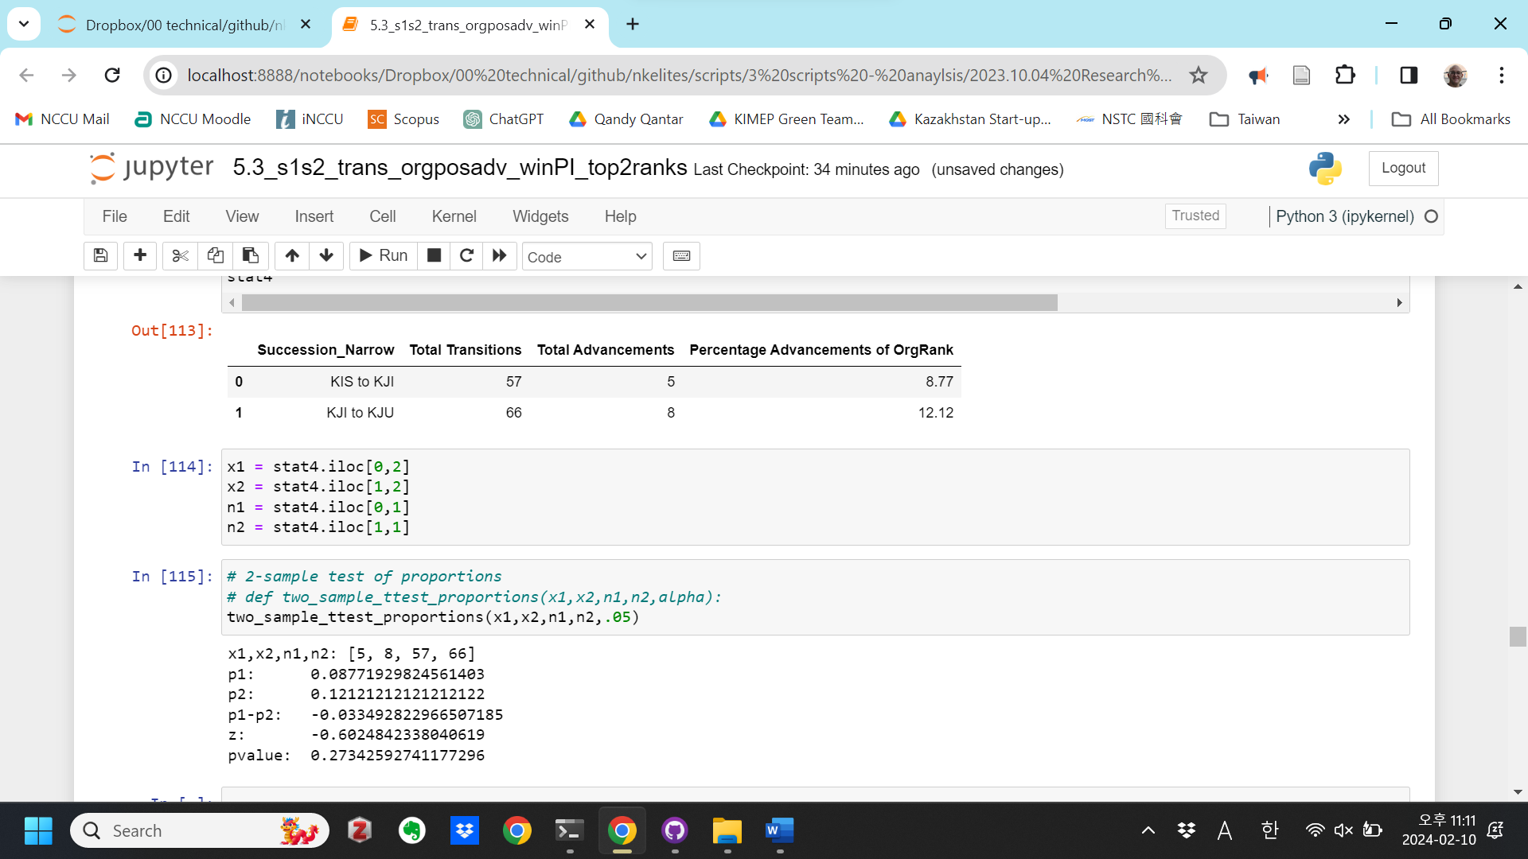

**# Hypothesis 2b - Position Advancement, narrow succession periods**

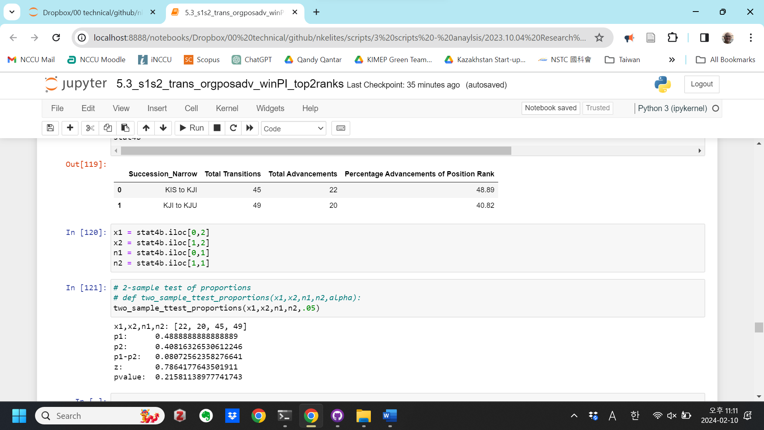

**# Hypothesis 2c - Org Advancement, narrow succession, by Institution**

Government

Succession_Narrow Total Transitions Total Advancements \

0 KIS to KJI 33 3

1 KJI to KJU 53 7

Percentage Advancements of OrgRank

0 9.09

1 13.21

x1,x2,n1,n2: [3, 7, 33, 53]

p1: 0.09090909090909091

p2: 0.1320754716981132

p1-p2: -0.041166380789022294

z: -0.5791352785399175

pvalue: 0.2812489487237354

Social

Succession_Narrow Total Transitions Total Advancements \

0 KIS to KJI 6 1

1 KJI to KJU 1 False

Percentage Advancements of OrgRank

0 16.67

1 0.00

x1,x2,n1,n2: [1, False, 6, 1]

p1: 0.16666666666666666

p2: 0.0

p1-p2: 0.16666666666666666

z: 0.44095855184409843

pvalue: 0.32962150184631533

Party

Succession_Narrow Total Transitions Total Advancements \

0 KIS to KJI 13 0

1 KJI to KJU 0 0

Percentage Advancements of OrgRank

0 0.0

1 NaN

x1,x2,n1,n2: [0, 0, 13, 0]

p1: 0.0

p2: nan

p1-p2: nan

z: nan

pvalue: nan

Military

Succession_Narrow Total Transitions Total Advancements \

0 KIS to KJI 5 1

1 KJI to KJU 12 1

Percentage Advancements of OrgRank

0 20.00

1 8.33

x1,x2,n1,n2: [1, 1, 5, 12]

p1: 0.2

p2: 0.08333333333333333

p1-p2: 0.11666666666666668

z: 0.6802777210652852

pvalue: 0.2481643142368739

**# Hypothesis 2d - Position Advancement, narrow succession, by Institution**

Government

Succession_Narrow Total Transitions Total Advancements \

0 KIS to KJI 25 16

1 KJI to KJU 42 13

Percentage Advancements

0 64.00

1 30.95

x1,x2,n1,n2: [16, 13, 25, 42]

p1: 0.64

p2: 0.30952380952380953

p1-p2: 0.3304761904761905

z: 2.640471166016987

pvalue: 0.0041395418644954995**

Social

Succession_Narrow Total Transitions Total Advancements \

0 KIS to KJI 5 3

1 KJI to KJU 0 0

Percentage Advancements

0 60.0

1 NaN

x1,x2,n1,n2: [3, 0, 5, 0]

p1: 0.6

p2: nan

p1-p2: nan

z: nan

pvalue: nan

Party

Succession_Narrow Total Transitions Total Advancements \

0 KIS to KJI 12 0

1 KJI to KJU 0 0

Percentage Advancements

0 0.0

1 NaN

x1,x2,n1,n2: [0, 0, 12, 0]

p1: 0.0

p2: nan

p1-p2: nan

z: nan

pvalue: nan

Military

Succession_Narrow Total Transitions Total Advancements \

0 KIS to KJI 3 3

1 KJI to KJU 7 7

Percentage Advancements

0 100.0

1 100.0

x1,x2,n1,n2: [3, 7, 3, 7]

p1: 1.0

p2: 1.0

p1-p2: 0.0

z: nan

pvalue: nan